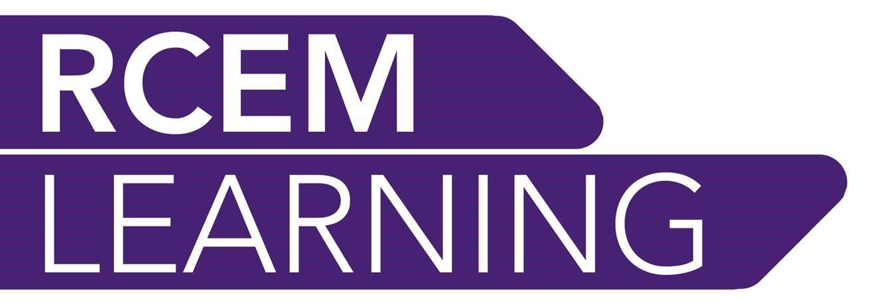

RCEMLearning Digital Education Fellows

Introduction
RCEMLearning has grown significantly in recent years. Two versions of the site have been successfully launched (in the spring of 2015 and 2017), and it is now embedded into the educational practice of the RCEM and wider EM community. RCEMLearning innovatively combines a Virtual Learning Environment (VLE) with Free Open Access Medical (FOAMed) resources, and it makes an invaluable contribution to how RCEM Fellows and Members prepare for exams, deliver teaching, refine critical appraisal skills, stay aligned with changes in evidence-based medicine, and maintain their eportfolio and CPD activities.
As a result of RCEMLearning’s continued growth, the RCEM is looking to appoint up to two Digital Education Fellows (DEFs)to support the platform’s pioneering work:
- Trust/health board-sponsored DEFs: Successful applicants will work within their hospitals but have protected time for RCEMLearning activities on an 80:20 split.
- As part of the DEF the RCEM will also fund a postgraduate qualification (PgDIP, PgCERT etc.) for successful candidates up to a maximum of £4.000 per year. Successful candidates will be expected to devote a significant proportion of their course to a research-based or practical output (e.g. designing and implementing a flipped classroom model, a dissertation predicated on the site’s educational ethos etc.) based on RCEMLearning.
The remainder of the document will outline the purpose of the role, the mechanisms for selecting host sites, time lines and person specification for potential candidates.
Role purpose
The fellows will support the following activities:
- Deliver new content across the site, or for specific sections (FOAMed, assessed Exams and CPD content etc.) to support the RCEM’s Educational Strategic Objectives
- Strategically manage and be directly involved in the editorial review of existing content
- Ensure RCEMLearning content represents the heterogenous educational and professional development requirements of the College’s diverse membership
- Help conceptualise and implement RCEMLearning’s pedagogies
- Sit on RCEMLearning’s Editorial Executive
- Conduct research into digital learning’s impact on education within the specialty, and its efficacy for individual learners
- Help embed RCEMLearning into conventional teaching practices of departments
- Embed the new RCEM curriculum into the site’s educational and conceptual ethos
Structure
Fellowships will be created for the 2021-22 training year; they will start in August 2021 and conclude in July 2022. Sponsored DEF candidates will spend 80% of time working in the ED, with the remaining 20% representing protected time for RCEMLearning-related work. LTFT candidates are welcome to apply. The DEFs will be a whole-time post on a fixed-term contract for 12 months, with a review at 6 months.
The majority of the work will be conducted locally but candidates will be required to travel to RCEM offices, RCEM events and external meetings on occasion and with prior agreement. RCEMLearning will cover expenses where appropriate when attendance is required at external meetings and events. Successful applicants will work closely within RCEMLearning and RCEM governance structures to ensure objectives are fulfilled.
Shortlisted candidates will be notified no later than two weeks after the closing date.
Time | Step
02 November 2020 | Application process begins for host sites
30 November 2020 | Application process closes for host sites
18 December 2020 | Host sites confirmed by RCEM
January 2021 | Application process for individuals commences at local level
February 2021 | Interviews  Appointments confirmed
August 2021 | DEFs begin
February 2022 | Six-month review of DEFs

Application process
Host sites need to be identified before the recruitment process for individuals commences. Interested trusts and hospitals are advised to write to the RCEM to outline their suitability for hosting the DEFs. Hospitals can apply to host one or both of the DEFs. Host sites will be confirmed by a panel at RCEM comprised of the Deputy Chief Executive, a RCEM Officer and the RCEMLearning Clinical Chair/Representative from the RCEMLearning Editorial Executive. Successful site[s] would then recruit according to their local policies and governance structures would be (we would like to have an RCEMLearning representative on the interview panel), but it is expected the process will align with the person specification details outlined below.
The following criteria needs to be fulfilled and evidenced in order for hospitals to be shortlisted:
- Approval from the clinical director
- Examples of delivering similar fellowship roles, or a clear rationale for wanting to introduce them
- A demonstrable commitment to delivering innovative and effective educational practices
- Examples of educational activity (with an emphasis on digital education) that have had a demonstrable impact on departmental or individual learning
- An indication of how these fellowships would be used to advance digital education
Person specification
The College requires applicants to adhere to the following criteria:
Essential | Desirable
On the GMC register, with a licence to practise and no limitations on practise
A member in good standing with the RCEM
ST4 or equivalent in a substantive post
Ability to demonstrate evidence of excellent educational activity
Evidence of an educational portfolio commensurate with grade/role | Record of presenting at conferences, engagement with research activities, publication record (in traditional or digital environments) commensurate with grade/role
Demonstrable contribution to/interest in digital medical education via creation of own content, peer review activities, FOAMed production etc. | Post-graduate or equivalent qualification in medical or digital education

Please contact James Folan on james.folan@rcem.ac.uk with any questions about the roles or recruitment process. Applications should be emailed to James by 30 November 2020.

